**TOYOTA MANAGER HELPER**

**Summary:**

This application help managers quickly view and sort available cars.

**Example of use:**

If you running this console application you see menu with 5 case’s.

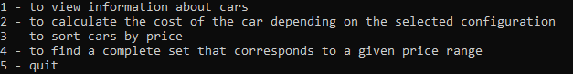

Enter 1 – to view list about cars which is included to the application directory, file name is “CarsAvailable.txt”.

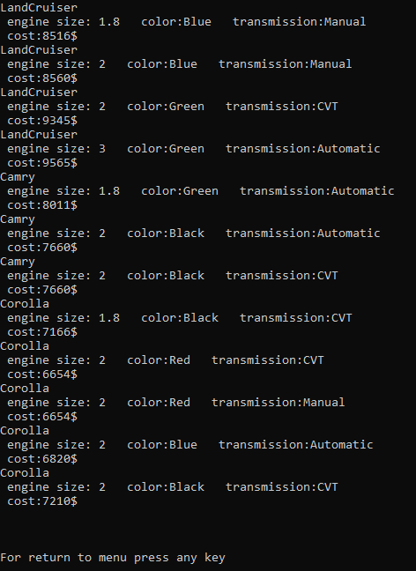

Press any key to return to the menu.

Enter 2 – to calculate the cost of the car depending on the selected configuration.

1. Then you can choose one of the 3 presented models: 1 – LandCruiser, 2 – Camry, 3 – Corolla.
2. For example, select 3, then you need choose one of the presented size of engine: 1 - 1.8, 2 - 2.0, 3 - 3.0.
3. For example, select 2, then you need choose one of the presented color: 1-Green, 2-Black, 3-Red, 4-Blue.
4. For example, select 4, then you need choose one of the presented transmission: 1-Manual, 2-Automatic, 3-CVT.
5. For example, select 2. After that you will see information about your chosen configuration.

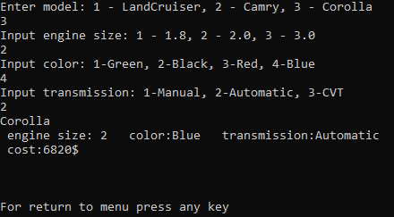

If you enter incorrect data in any of the points above items, you will receive an error message.

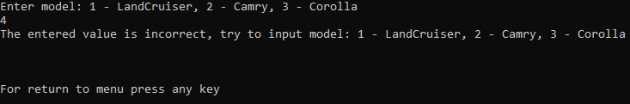

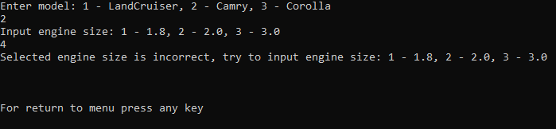

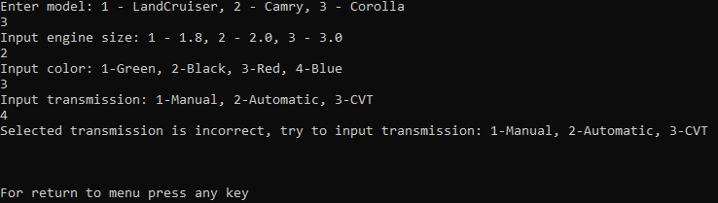

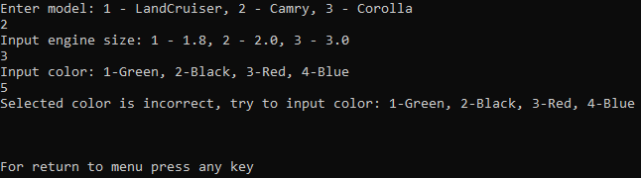

Enter 3 – to sort cars by price.

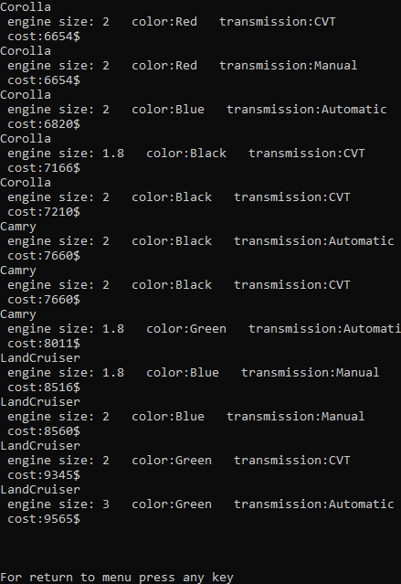

For return to menu press any key.

Enter 4 – to find a complete set that corresponds to a given price range, you will need to enter starting price and ending price of the range, if you enter a ending price less than the starting price, you will get an error.

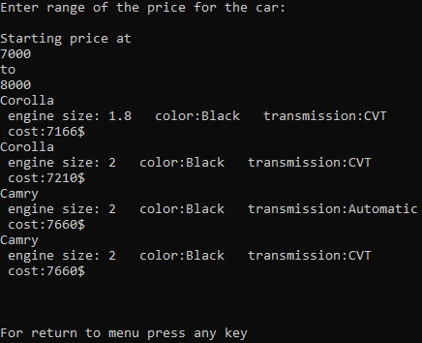

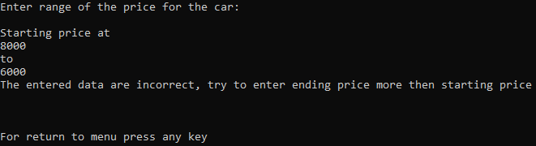

For return to menu press any key.

Enter 5 – to exit of the application.